OPIS OSOBY/ description of the person
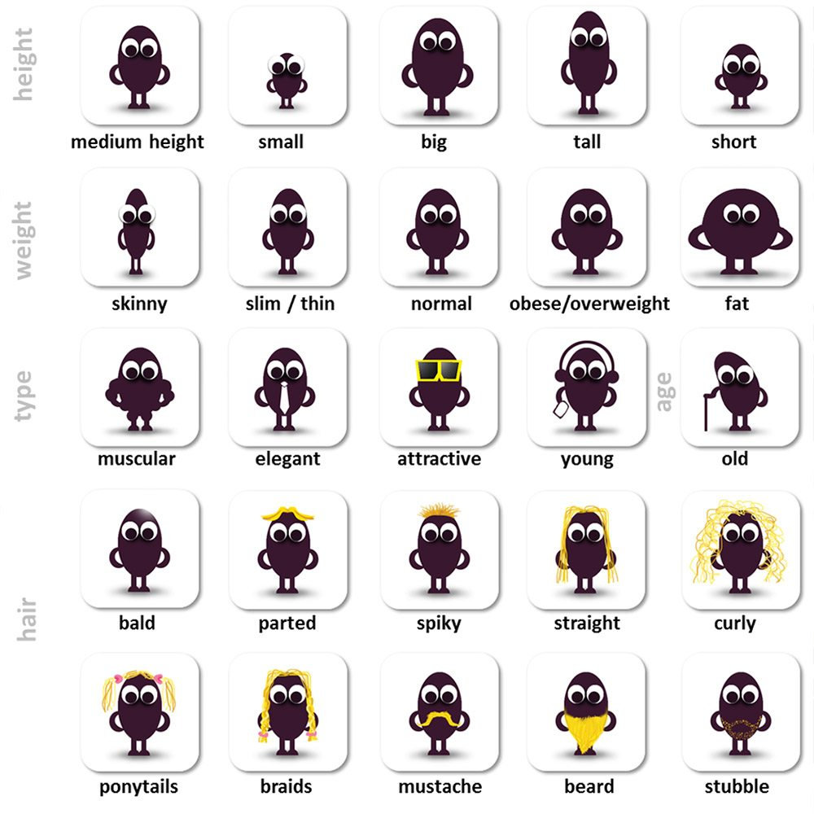

Popis osoby - Person description / Appearance

Appearance | Epírens | Vzhľad
attractive | atraktiv | atraktívny
good-looking | gud luking | pekný / fešný
beautiful | bjútifl | krásny
handsome | hendsam | pekný / krásny (človek)
pretty | prity | pekný
cute | kjút | milý, rozkošný
nice | najs | milý
plain | plejn | nepekný
ugly | agly | škaredý
neat | nít | upravený, vkusný
clean | klín | čistý
dirty | drty | špinavý

Height | Hejt | Výška
tall | tól | vysoký
short | šort | nízky
average/medium hight | evridž/mídium hejt | priemern / stredne vysoký

Weight (build) | Vejt (bild) | Váha (postava)
slender | slendr | štíhly
thin / slim | "s"in / slim | tenký, chudý
skinny | skiny | kosť a koža (vychudnutý)
medium-build | mídium bilt | stredná postava
strong | strong | silný
muscular | maskular | svalnatý
athletic | atletik | aletický / vyšportovaný
overweight | ovrvejt | s nadváhou
obese | obéz | obézny
fat | fet | tučný
Vypočujte si slovíčka z tabuľky s anglickým prízvukom

Ako opísať tvár? Vlasy a účesy po anglicky
Hair | Hér | Vlasy
dark | dark | tmavé
blond | blond | blond
red | red | ryšavé
gray | grej | šedivé
long | long | dlhé
short | šort | krátke
shoulder-length | šoldr lengt | po ramená
straight | strejt | rovné
curly | kŕly | kučeravé
wavy | vejvy | vlnité
thick | "s"ik | husté
thinning | "s"ining | rednúce
bald | bold | plešatý / holohlavý
smooth | smú"s" | jemné
disheveled | diševld | strapaté
ponytail | ponytejl | cop
plait/braid | plejt/brejd | vrkoč
bun | ban | drdol
fringe/bangs | frindž/bengs | ofina
parting/part | parting/part | cestička
beard | bírd | brada
moustache | mastéč | fúzy
stubble | stabl | strnisko

My mother
My mother is the most important person in my life – with my father also, of course. I know her all my life. It is mother who we have some troubles and is ready to answer every question which comes .ϑto mind. My mum is my friend
She is called Dagmar. She is thirty-eight and she lives with me, sister, brother and my dad in a family house. My mum is clerk. She doesn’t play sport, bat she has got other hobbies.
She likes working in the garden. She likes flowers but our dog destroys them! She grows vegetables and fruits too. For example, her tomatoes, cucumbers, strawberry and apples are very delicious! My mum likes cooking too. She likes watching TV, especially soap operas but she doesn’t like advertising! She doesn’t like cleaning too.
My mum isn’t very tall. She wears sports and fashionable clothes. She has got short, dark, straight hair and blue eyes. She always wears glasses. My mum doesn’t wear lots of make-up; she wears only mascara and eye shadow.
She is truly interested in the problems of her friends or family and listens to him/her patiently every time he/she needs it. I can trust her with my secrets; she can keep them as if they are her own. She is friendly, patient and likable.

