OPIS miesta/descript of the place
airport  alley  apartment  ​ building  art gallery  bakery  bank  bank machine  3 barbershop  bookstore  bowling alley  bridge  bus stop | cemetery  ​church  clinic  coffee shop  college  1convenience  ​ store  crosswalk  department  ​ store  2downtown  factory  fire station  garage | gas station  ​grocery store  ​gym  hair salon  hospital  hotel  house  Internet cafe  intersection  4laundromat  law court  library  5mosque | movie theater  ​museum  ​neighborhood  news stand  office building  park  parking lot  pet store  pharmacy  playground  police station  port  post office | prison  ​restaurant  ​school  shopping mall  sidewalk  stadium  suburbs  subway  supermarket  6temple  train station  university  ​zoo
https://www.allthingstopics.com/places-around-town.html
1-obchod so zmiešaným tovarom, 2 – centrum mesta,3-holičstvo,4 – práčovne,5-mešita,6-chrám,
beautiful  bright  crowded  dirty  ​ empty | expensive  large  messy  modern  ​neat | new  noisy  spacious/priestranný, rozľahlý  tall  ​traditional
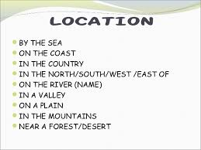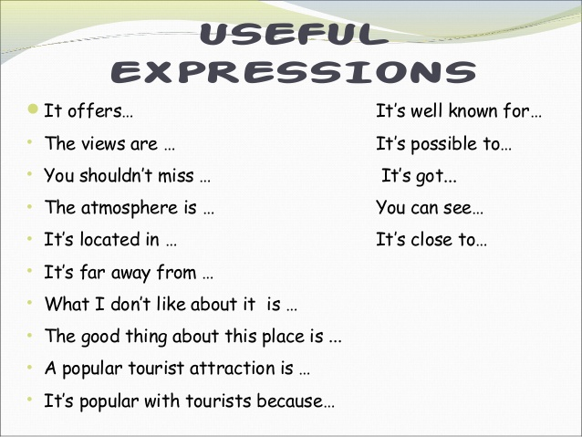
Place of my dreams:
Place of my dreams is on this planet. Earth is interesting enough to be a place of someone’s dreams because of its variety of cultures and landscapes. If only the peace was all over the world. Then any place could be a place of someone’s dreams. This year I was in Low Tatras for 6 days. If only you saw that beauty! I couldn’t be angry with anyone, I couldn’t be worried, unhappy or unsatisfied. I just couldn’t. One view on wonderful hills, which braided (vpletať sa) in each other was enough to warm the heart, to cheer the mind and the soul. The nature was so beautiful, that it took me the breath. I wish you had been there with me and had seen it. This is the nicest place, I have ever seen. This place made me a better person. This is the place of my dreams.
My home town
I live in a small and beautiful town with population of about 17 000 people. This town is called Snina and it is situated in the east of Slovakia.
I think that there are lots of munuments. We have got two churches. Older of them is the Church of St. Jacob and it lies near by hotel Kriváň. Second church is called St. Marian church which is built in the lower part of the town.
There is a Square of freedom and in the middle of this square there is a statue of Ján Nepomucký. Kysucké Nové Mesto has restaurants, pubs and cafés. There are many shops and the most of them are clothes - shops. We have also big department stores like Billa, Jednota or Lidl. In the free time we can go to the library or to the cinema.
The main industries is engineering. There are about nine firms like Reamos Instal or Pentatech, but the biggest firms are INA and KLF. In this town, we have five schools. Two schools are primary. Next we have secondary grammar school, industrial school and And there are some kindergartens, too.
I think that nature is very nice but river is very inpure. In summer we can go for walks to the forest or we can frizzle and in winter there is a lot of snow so we can sled or build snowmans.
I like KNM because i have a lot of friends here and it is really lovely place.

